Omega Homes - Best Tip for Building a Custom Home in a New Subdivision

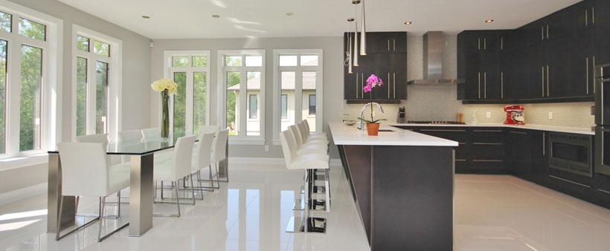

There are many new communities being planned all over Ottawa and one could be the perfect location for your new home. Building a custom home in a new subdivision comes with many advantages, but the process can feel overwhelming. The best tip when looking to build a house in a new development is to partner with the right home builder.

When choosing a custom home builder, you should look at their past work to get a sense of the type of homes they build and ask for references from past clients. The builder should also be open and transparent about the whole process—outlining what to expect and answering any questions you may have.

You should also ask about the company’s experience with building homes in a new development. There can be additional requirements to follow in new subdivisions, either from the developer or the city, and it’s important your home builder has the knowledge to navigate these requirements.

It can be hard for the average person to navigate the requirements needed for building a home in a new subdivision, but the right partner will be able to help you through the process, from choosing the right lot to helping you with the final landscaping touches.

Omega Homes is building homes in three new subdivisions in Ottawa,
Lakeland Meadows, McGee Meadow Estates and Lakewood Trails.

Contact us today to learn more about building a custom home
in one of these new communities.

At Omega Homes, we employ a group of top architects, designers and trades that allow us to turn your dream into a reality. We don’t just build you a house, we build you a home.

Want to see our past work? Follow us on Facebook, Twitter and Instagram
to see galleries of our Ottawa area custom homes.

